**Data Visualization**

1.

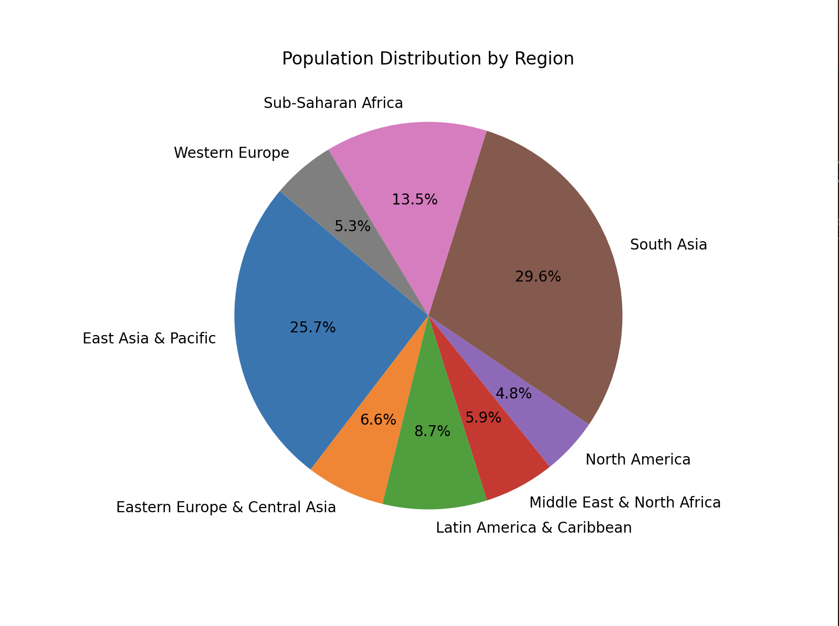

On this graph, We can see the population distribution by zones, as we can see the most populated aeras are South-Asia and East Asia & Pacific and the least populated area is North America.

2.

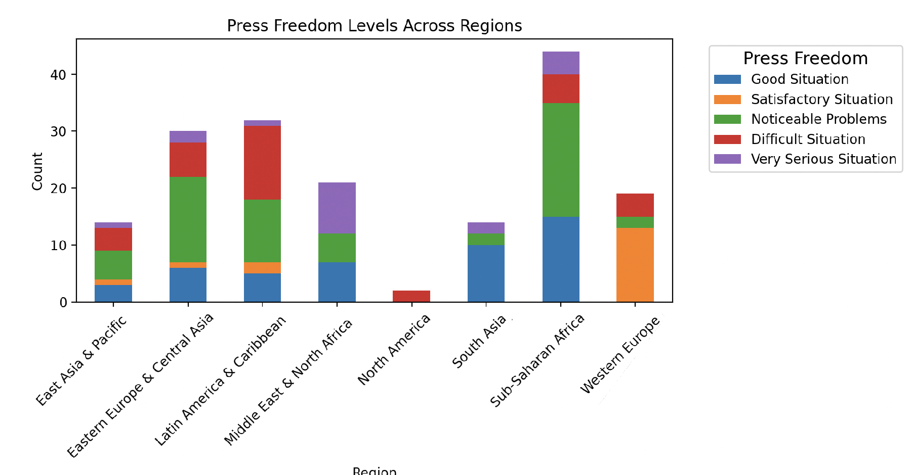

On this graph, we see the different Press Freedom levels across regions, we can see for example that Western Europe does not have countries in difficult situation level and that Middle East is the zone with the most countries in serious situation level.

3.

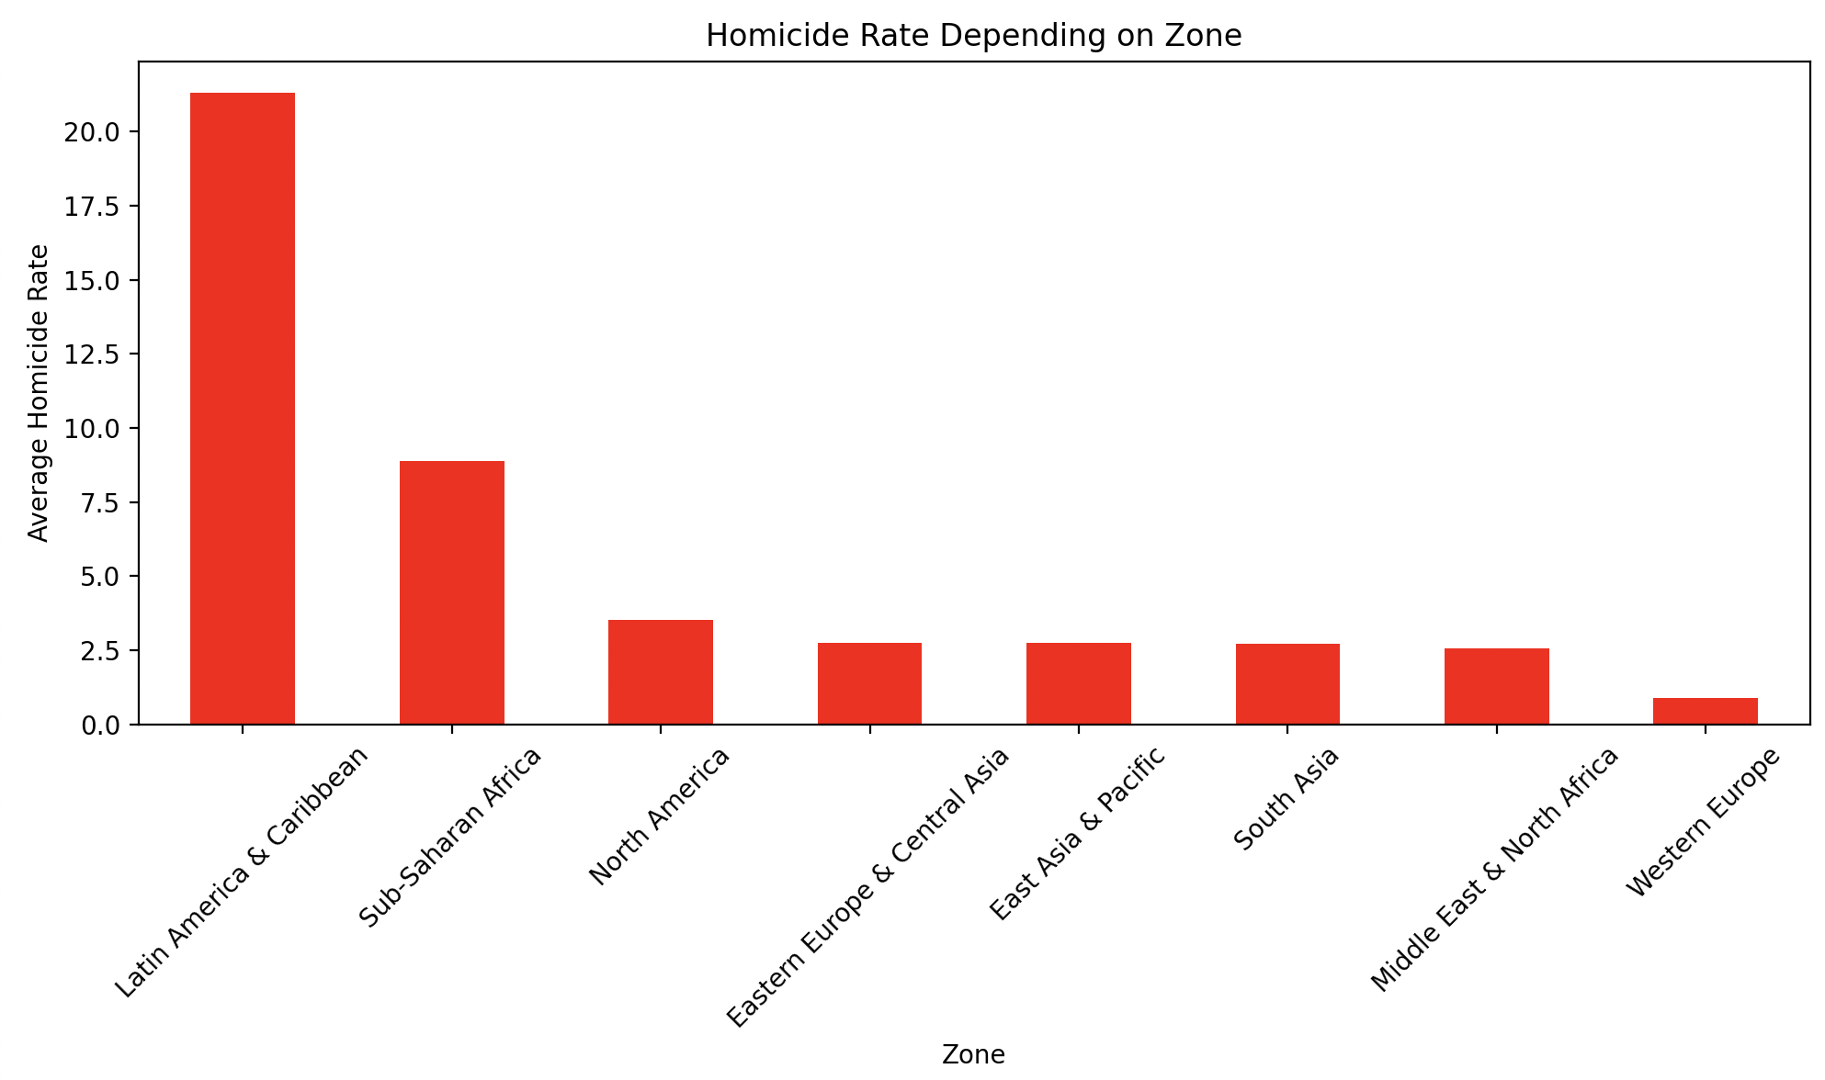

We can clearly see that the homicide rate in Latin America & Caribbean is as least twice bigger than in any other zone in the world and is more than 10 times bigger than the homicide rate in Western Europe.

4.

We can see on this graph that Belgium has the biggest homicide rate compare to the other countries in Western Europe.

5.

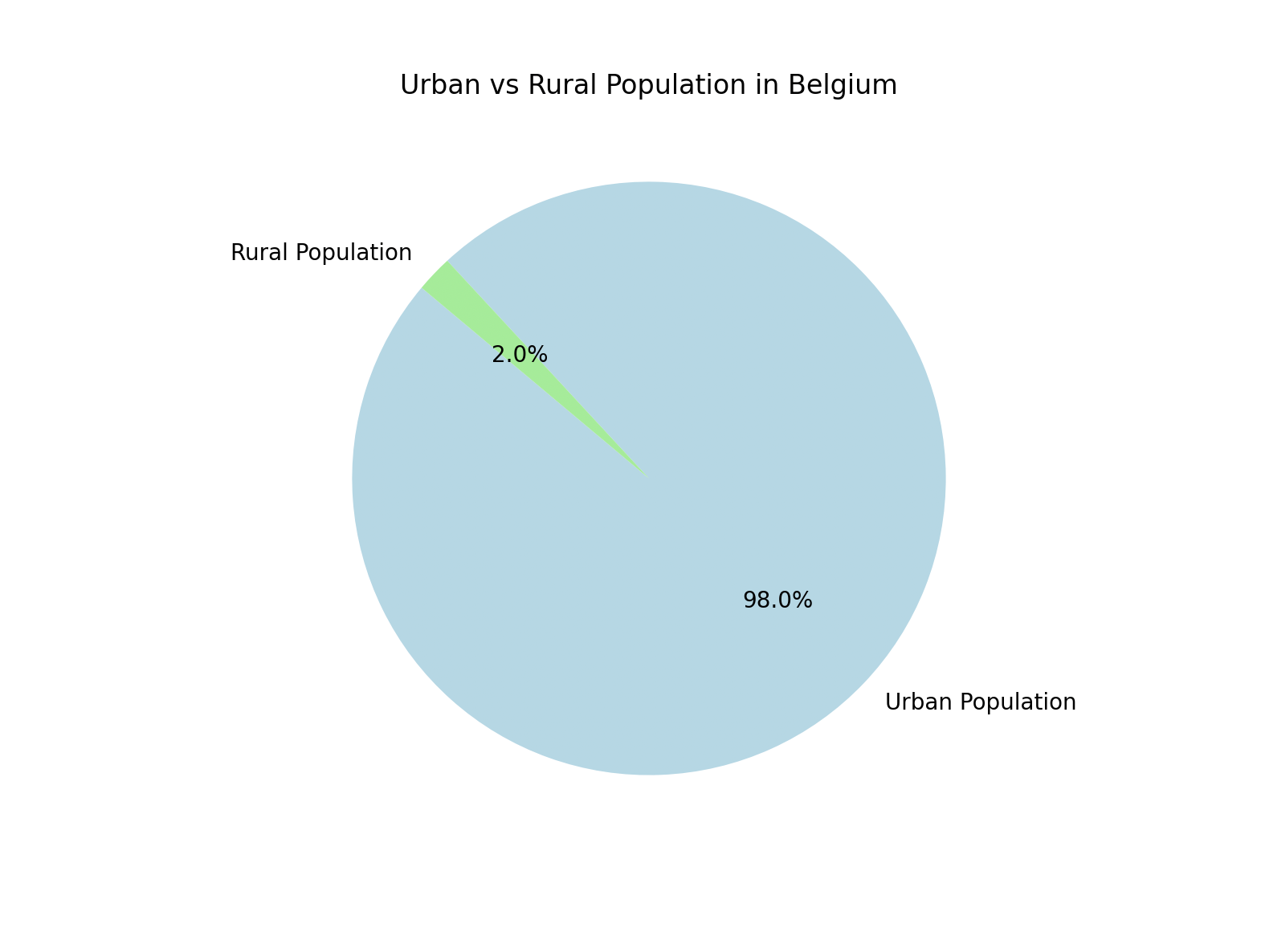

We can see on this graph that a huge amount of the population in Belgium lives in urban areas and only 2% of the population lives in rural areas.